***Odessa National Economic University*** was founded in 1921. Today it is one of the leading higher educational establishments of Ukraine in the field of economics, and is also a member of the European Association of universities (EUA).

ONEU trains highly qualified economists (bachelors, specialists and masters) in different directions and specialties, and also gives an opportunity for further training - postgraduate study and doctoral studies.

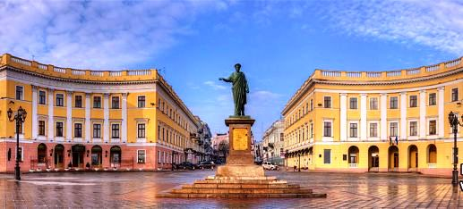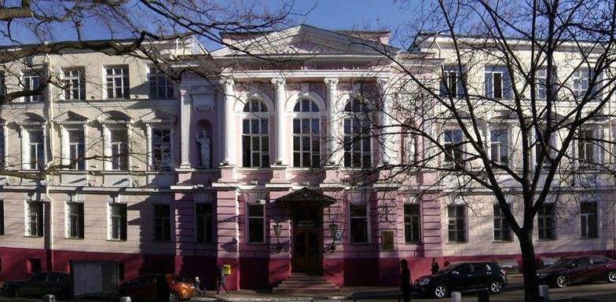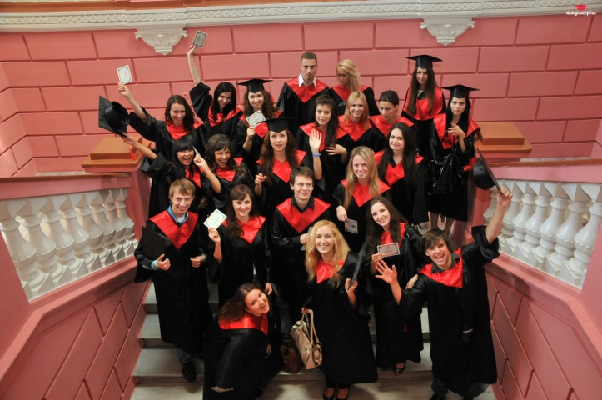***Contact information***

***ONEU web site: http://oneu.edu.ua/***

***International relations department:***

*Tel.: +38 (0482) 32-79-16, 35-81-60;*

*E-mail: ird@oneu.edu.ua*

*Adress: 8, Preobrazhenskaya str., room 125, Оdessa, 65082 Ukraine*

***George Shubartovsky – Deputy rector of international relations***

*Tel.: +38 (048) 723-11-81*

*E-mail: george@oneu.edu.ua*

***Viktor Gerasymenko – professor,***

***Head of the Department of Tourism, Hotel and Restaurant Business***

*Tel.: +38 (048) 722-01-22;*

*+ 38 (067) 786-23-15*

*E-mail: [325662@mail.ru](mailto:325662@mail.ru);*

*v.gerasymenko@gmail.com*

***Kateryna Galasiuk – PhD, Department of Tourism, Hotel and Restaurant Business***

*Tel.: +38 (067) 55-75-860*

*E-mail : kateryna.galasiuk@gmail.com*

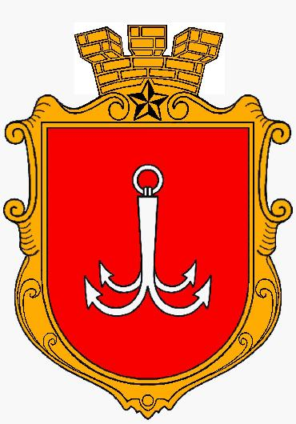

***Odessa national economic university***

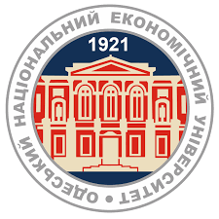

***Department of Tourism, Hotel and Restaurant Business***

ONEU develops the international cooperation with educational and scientific centers of the world and outstanding scientists of other countries, it carries out an exchange of students, post-graduate students and teachers.



The main objective of international cooperation at the university is the integration into the global educational environment through its participation in international programs and cooperation with foreign educational institutions, the extension of teaching staff, researchers’ and students’ mobility and the attraction of foreign citizens to enter the University.

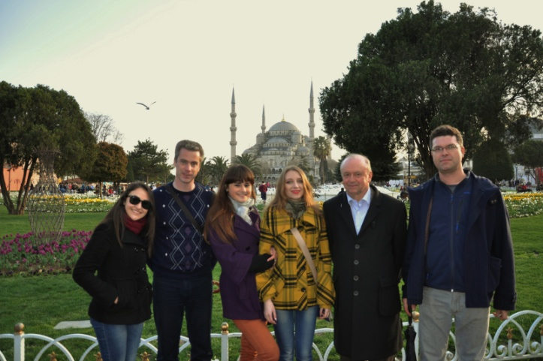 ***Department of Tourism, Hotel and Restaurant Business*** was founded in 2003 and provides education the directions: «Tourism» and «Hotel and Restaurant business» (Bachelor and Master educational-qualification levels).

The department has established creative relationships with famous universities of the world and international organizations:

♦ University of National and World Economy, Sofia, Bulgaria;

♦ Academy of Physical Education and Sport, Gdansk, Poland;

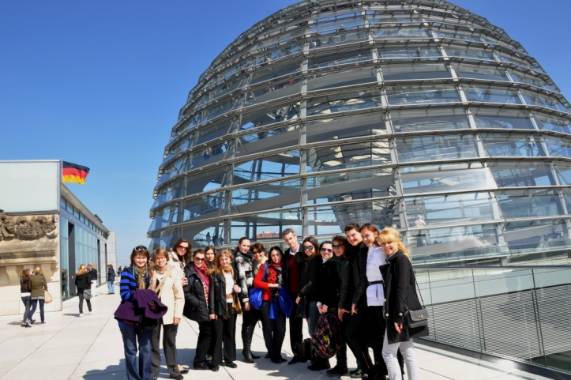♦ Institute of Tourism of Vienna Economic University, Vienna, Austria;

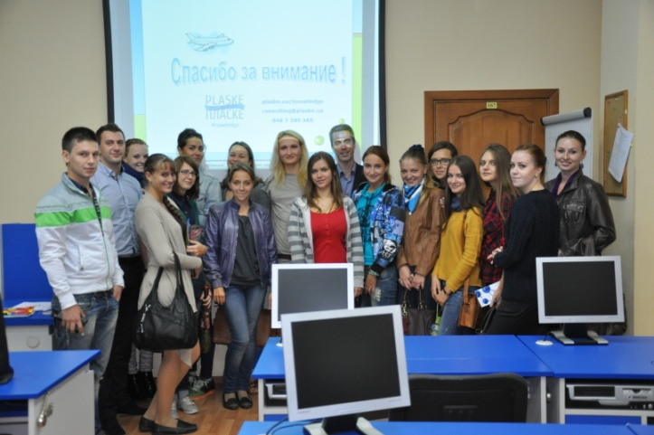♦ Varna Economic University, Varna, Bulgaria;

♦ University of Ariel, Ariel, Israel;

♦ Technological Education University of Ceres, Greece;

♦ University of Angers, Angers, France;

♦ International Foundation Romualdo del Bianco, Florence, Italy;

♦ Istanbul Ticaret University, Istanbul, Turkey.

The University always takes part in different international projects and programs (DAAD, SIFE, TEMPUS-TACIS, AIESEC etc.).

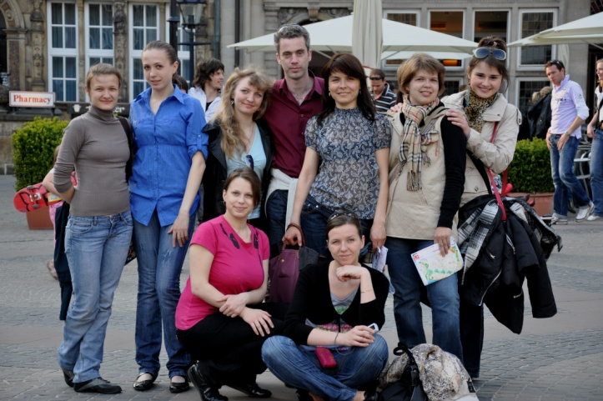In accordance with the requirements of the Bologna Declaration the mobility of students and teachers is increasing. The number of foreign professionals visiting ONEU as well as the number of students and teachers going abroad to study and to do research is gaining in scope every year.

Due to the concluded agreements on double diplomas every year the students are sent to study to Germany (University of Applied Sciences in Mittweida) and to France (University of Strasbourg).